All About Me
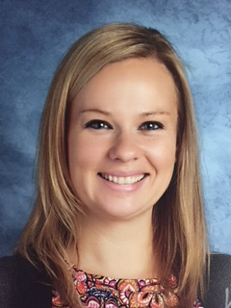

My name is Mrs. Fortin. I am a second grade teacher at Turkey Hill School. This will be my 10th year teaching in Orange. I have taught 3rd grade for seven years and 2nd grade for two.

Educational Background:
I received my bachelor's degree from the University of Connecticut in early childhood development in 2004. After a few years of teaching preschool I decided it was time to go back to school and get my masters in elementary education. I received my masters from the University of New Haven in 2008.

Personal Life:
I married my husband in 2015. He also works at Turkey Hill School and is a 4th grade teacher. We have a son name Jason Thomas (JT) and a dog named Sonny. We love spending time together and going for walks.

