 | MONDAY | TUESDAY | WEDNESDAY | THURSDAY | FRIDAY
3:15-3:45 | Sign-in and snack | Sign-in and snack | Sign-in and snack | Sign-in and snack | Sign-in and snack
3:45-5:00 | Homework Club with teachers  Games/Legos/Art | Homework Club with teachers  Games/Legos/Art | Homework Club  Games/Legos/Art | Homework with teachers  Games/Legos/Art | Homework Club  Games/Legos/Art
3:45-5:00 | Outside/gym  Football 4-6  Parachute games k-3 | Outside/ gym  Kickball game k-3  Tennis racket baseball 4-6 | Outside/ gym  Kickball game 4-6  Basketball game k-3 | Outside/gym  Four square k-3  Tennis racket baseball 4-6 | Outside/gym  Soccer game k-3  Flag football 4-6
3:30-5:00 | Craft: Reindeer hat | Cooking: Apple pancakes  STEM: Paint our “aircraft carrier” | Craft: Duct tape fun | Art: Marble painting  Crafts: Bottle tab bracelets | Craft: Iron bead designs
5:00-6:00 | Outside/gym  Games/Legos/Art | Outside/gym  Games/Legos/Art | Outside/gym  Games/Legos/Art | Outside/gym  Games/Legos/Art | Outside/gym  Games/Legos/Art
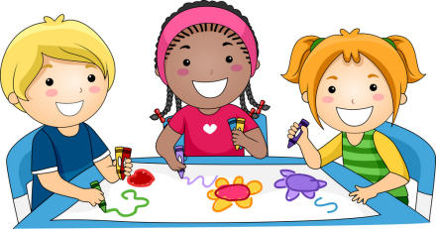
WEEKLY 21ST SCHEDULE
THE PECK PLACE SCHOOL
Week of 11/27/17 through 12/1/17

