 | MONDAY | TUESDAY | WEDNESDAY | THURSDAY | FRIDAY
3:00-3:25 | Sign-in and snack | Sign-in and snack | Sign-in and snack | N  O | Sign-in and snack  Raccoon Awards
3:25-4:00 | Homework  Outside/Gym  Legos | Homework  Storytime (K)  Outside/Gym | Homework  4-suare  Outside/Gym | S  C | Kick Ball Game  Outside/Gym  Chalk Art
4:15-5:15 | Kickball game  Paper Apple craft | MOVIE DAY!  Gym Games  Paper Apple Craft  Computers | Computers  Ironing Beads  Basketball Game | H  O | Outside/gym  Computers  Soccer Game (1-3)  Coloring
5:00-6:00 | Free Play  Chess Matches  Barbies | Board Games/Legos  Chinese Checks  Magnet building | Board Games/Legos  Car races  Pirates/Ship  Legos | O  L | Board Games/Legos  Build your own Farm  Building Block Sky Scrapers
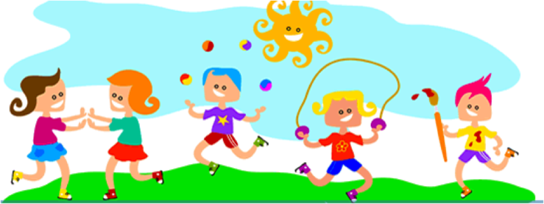
WEEKLY 21ST SCHEDULE
RACE BROOK SCHOOL
Week of 9/18/17 through 9/22/17

