 | MONDAY | TUESDAY | WEDNESDAY | THURSDAY | FRIDAY
3:00-4:30 | Sign in and snack  Lego League  Basketball Club | HALLOWEEN  Sign in and snack  Cooking/Flag Football | Sign in and snack  Tennis/Chess | Sign in and snack  Karate | Sign in and snack  Raccoon Award Day  6th Grade Snack Serving
3:20-4:20 | Homework Club  Gym Games  Ping Pong  Cupcake Baking | Homework Club  Craft  Outside/Gym | Homework  Gym/Outside  Chess/Tennis | Homework Club  Pumpkin Playdoh  Blanket Making | Free Day  Outside/Gym  Cooking
4:00-5:30 | Computers  Basketball Game  Popsicle stick scarecrows | Outside/Gym Games  Computers | Computers  Jewelry Making  Craft  STEM GAMES | Outside/Gym  Kickball Game  Parachute (K) | Computers  Soccer Game (1-3)
5:30-6:00 | Board Games/Legos  Car Races  Chess  STEM games | Board Games/Legos  Chinese Checks  Magnet building | Board Games/Legos  Car races  Pirates/Ship | Board Games  Simon Contest  Train sets | Free Play  Kitchen
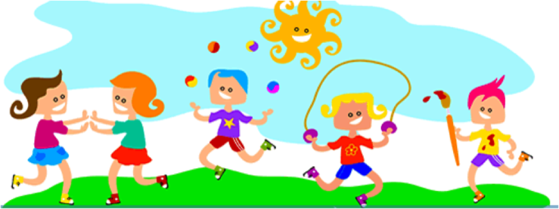
WEEKLY 21ST SCHEDULE
RACE BROOK SCHOOL
Week of 10/30/17 through 11/3/17

