 | MONDAY | TUESDAY | WEDNESDAY | THURSDAY | FRIDAY
3:15-3:45 | Sign-in and snack | Sign-in and snack | Sign-in and snack | Sign-in and snack | Sign-in and snack
3:45-5:00 | Homework Club with teachers  Games/Legos/Art | Homework Club with teachers  Games/Legos/Art | Homework Club  Games/Legos/Art | Homework with teachers  Games/Legos/Art | Homework Club  Games/Legos/Art
3:45-5:00 | Outside/gym  Flag football 4-6  Tennis racket baseball k-3 | Outside/ gym  Soccer game k-3  Basketball game 4-6 | Outside/ gym  Bean bag toe tag 4-6  Kickball game k-3 | Outside/gym  Bean bag toe tag k-3  Tennis racket baseball 4-6 | Outside/gym  Soccer game k-3  Flag football 4-6
3:30-5:00 | Craft: Complete painting “air craft carrier” | Cooking: Mozzarella sticks  Craft: “Present” for the holidays | Craft: Duct tape fun  Craft: Pompom bears | Art: Water color painting  STEM: Making slime (older grades) | Craft: Puffy paint painting
5:00-6:00 | Outside/gym  Games/Legos/Art | Outside/gym  Games/Legos/Art | Outside/gym  Games/Legos/Art | Outside/gym  Games/Legos/Art | Outside/gym  Games/Legos/Art
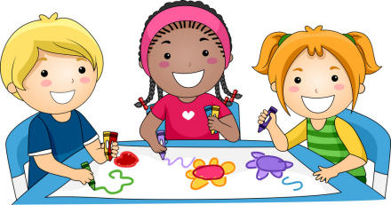
WEEKLY 21ST SCHEDULE
THE PECK PLACE SCHOOL
Week of 12/4/17 through 12/8/17

